Client Data Transfer Request Guide
To: All CSG Forte Customer Support, and Compliance Employees
Subject: Client Data Transfer Request Guide
From: Compliance Team
Date: April 13, 2021
___________________________________________________________________________________
Purpose:
The purpose of this document is to provide guidance on client data transfers request from clients (merchants) to other Forte merchants or PCI compliant third party.
Steps:
Validate PCI Status via the Visa Provider link or Mastercard Provider Download
- From the Visa website

- Complete Company name field and select search.

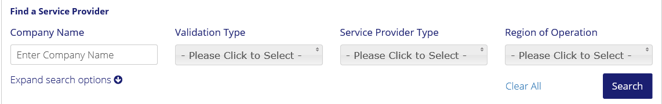
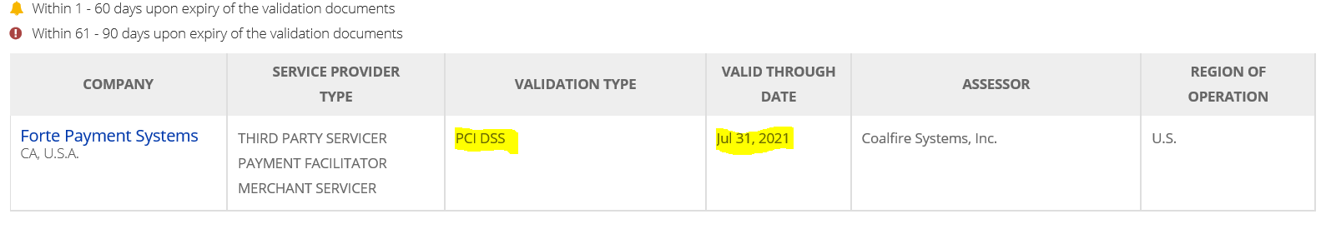
- If the search returns a Validation Type of PCI DSS and a Current Valid Good Through Date, this should be sufficient validation that the merchant is PCI Compliant.

- From the Mastercard website
- Scroll down the webpage until you come to “The Mastercard SDP Compliant Registered Service Provider List
- Select this option to download the List
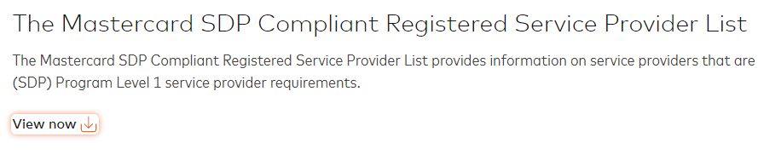
- Once downloaded
- View the Service Provider list for name of provider
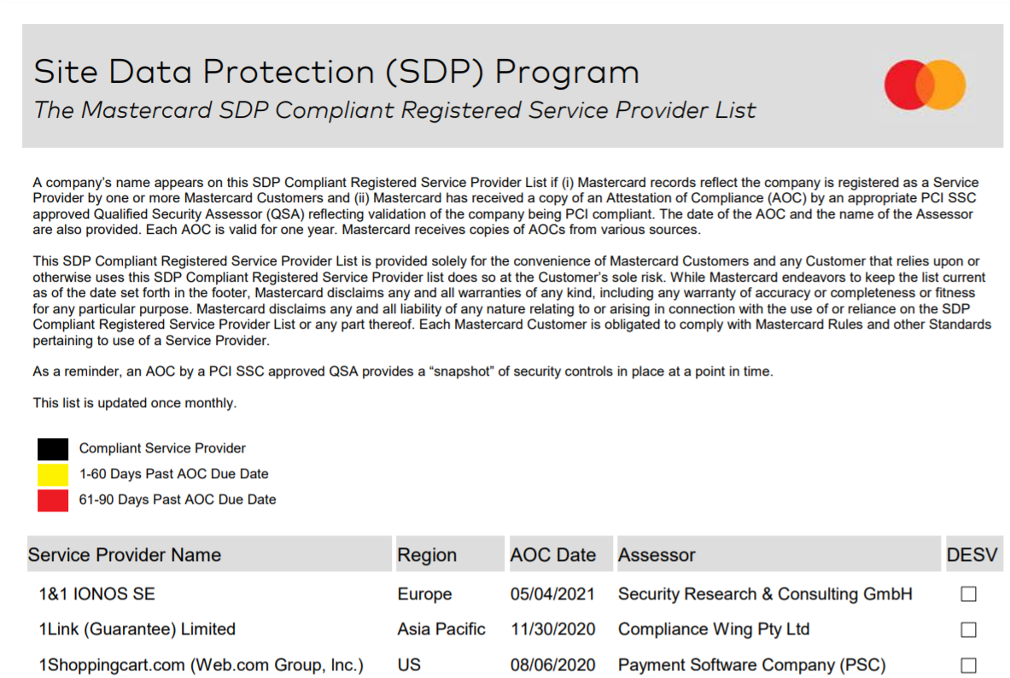

- Once located view the AOC Date Column to determine if the AOC Date is current
  - Dates in the font color (black/yellow/red) indicates compliance status.

